International Crime Free Association, Inc.

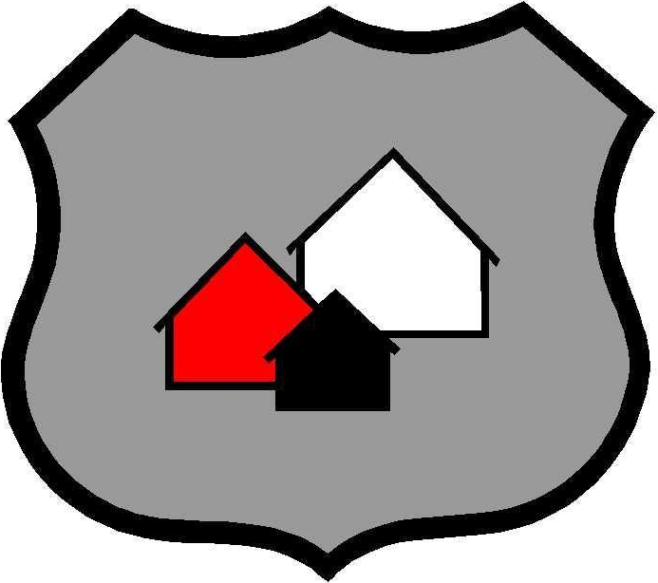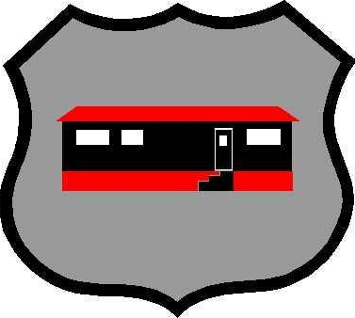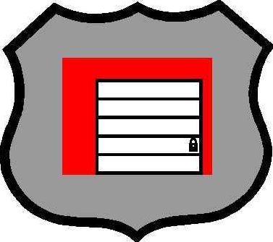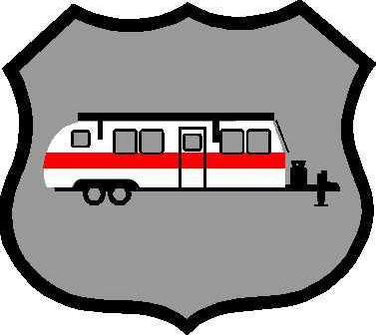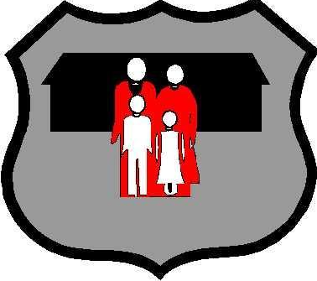
Multi-Housing Mobile Housing Self-Storage Hotel / Motel Condominiums RV Parks Business Lifestyle

Today’s Date

Your Title & Name – Your Agency Name
Your Street Address – Your City, State and ZIP Code
Your Phone # and Extension- Other Phone #
Your FAX Number – Your E-mail Address

Ref: Crime Free Multi-Housing Program Operating Agreement

Dear Your Title & Name:

Thank you for your interest in the Crime Free Multi-Housing Program (CFMHP) and obtaining a Copyright License to modify and reprint The International Crime Free Association’s CFMHP Workbook and the other related materials to suit your jurisdiction’s needs.

This Crime Free Multi-Housing Program Operating Agreement (Operating Agreement) outlines the terms and conditions for which the CFMHP shall operate within Your City, State. This Operating Agreement must be signed by a representative of Your Agency Name as a condition to hold a Crime Free Multi-Housing Program License Agreement (License Agreement) with the International Crime Free Association (ICFA) and to administrate the CFMHP in Your City, State.

The Your Agency Name CFMHP will be completely managed and administrated by the Your Agency Name, with assistance available from the International Crime Free Association, Inc.

ROLES
Your Agency Name Responsibilities:
-  Promoting the CFMHP in the Your City, State.
- Ensuring the CFMHP standards are met in Your City, State.
- Producing the workshop flyer and attendee registration forms.
- Maintaining a speaker’s bureau for CFMHP Workshops.
-  Administration and maintenance of the CFMHP workbooks, promotional items, certificates and other resources available for workshop attendees.

Your Agency Name Crime Free Multi-Housing Coordinator’s Responsibilities:
-  Compliance with this CFMHP Operating Agreement.
- CFMHP Coordinators must complete a CFMHP Train-the-Trainer course.
- Compliance with CFMHP Minimum Standards (listed below).
-  Promotion of the CFMHP in Your City, State.
-  Coordination of CFMHP Workshops in Your City, State.

LOGO, TRADEMARKS, AND SYMBOLS
The Your Agency Name’s limited (non-transferable) license for the CFMHP name, materials (workbook, certificates, and signage), Service Mark, and CFMHP Logo is given by the ICFA. All documentation and materials displaying the CFMHP name and logo may not be altered in any way without the approval of the International Crime Free Association, Inc.

CFMHP MINIMUM STANDARDS
The ICFA retains the right to set new CFMHP Minimum Standards in consultation with Your State CFMHP Coordinators. Any changes to these standards must be agreed upon by the majority of Your State CFMHP Coordinators and the ICFA.

Current CFMHP MINIMUM STANDARDS:
1. Use of the CFMHP Symbol as it is, Three houses inside a badge.
2. Use of the Service Mark: Crime Free Multi-Housing Program.
3. Multi-Phase CFMHP Certification Requirements:
a). Phase 1 (Green Certificate) – Requires 8-hour property management training workshop to include training on CFMHP overview, the Crime Free Lease Addendum, applicant screening, tenancy laws, and crime prevention security standards.
b). Phase 2 (Red Certificate) – Includes a “crime prevention security assessment” of the rental property by the local CFMHP Coordinator.
c). Phase 3 (Blue Certificate) – Each rental property (with more than 20 rental units) must host at least one Safety Social / Tenant Meeting to become fully certified in the CFMHP.
4. Annual Certification / Re-Certification (Gold Certificate) – An annual “crime prevention security assessment” and at least one Safety Social / Tenant Meeting must be completed by each rental property (with more than 20 rental units) for membership / continued membership in the Your Agency Name CFMHP, at the discretion of the Your City, State CFMHP Coordinator.

CFMHP Workbook:
The most important part of your CFMHP Workbook for The International Crime Free Association’s review is the copyright statement shown below. This statement must be printed as shown below, on the inside of the front cover, or the first page inside of your CFMHP Workbook.

The name of your city must be inserted at the indicated places below. PLEASE SEND A COMPLETED COPY OF YOUR COPYRIGHT STATEMENT TO THE I.C.F.A. BEFORE PUBLISHING MULTIPLE COPIES.

Copyright Statement

Copyright © 1996 by International Crime Free Association, Inc. All rights reserved. No parts of this book can be produced or transmitted in any form or by any means, electronic or mechanical, including photocopying, recording or by any storage or retrieval system without written permission from the International Crime Free Association, Inc., except for the inclusion of quotations in a review.

Copyright © 2012 Your Agency Name.  Portions of this workbook are reprinted and/or modified with permission from the International Crime Free Association, Inc.

The editorial decisions, reprinted and added texts are made by Your Agency Name, and do not necessarily reflect the views or opinions of the International Crime Free Association, Inc. These materials are copyright protected by the International Crime Free Association, Inc., and may not be duplicated without permission from the International Crime Free Association, Inc. and the Your Agency Name.

Copyright is granted to all law enforcement agencies at no cost, for the purposes of maintaining quality control of materials and a list of agencies participating in the International Crime Free Multi-Housing Program.

International Crime Free Association
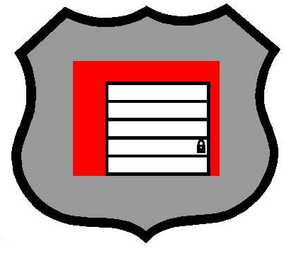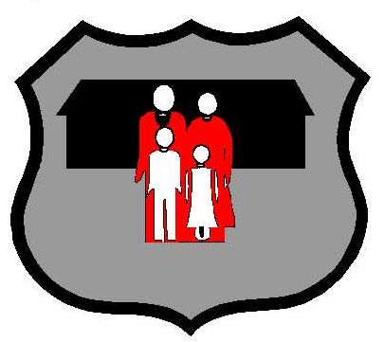

Multi-Housing Mobile-Housing Condominiums Mini-Storage Hotels/Motels Family Lifestyle Businesses

To validate this Crime Free Multi-Housing Program Operating Agreement, Please indicate your acceptance of the terms of this Operating Agreement set forth above, by signing and dating the final page of this letter, and mailing the original back to me.

By signing this Operating Agreement, the City operating the Crime Free Multi-Housing Program (CFMHP) understands the roles and responsibilities as set forth in this Operating Agreement and will comply with the CFMHP Minimum Standards set forth by the International Crime Free Association, Inc.

City Operating the CFMHP Program: __________________________________

Authorized Signature: ______________________________________________

Official Title: ______________________________________________________

Phone: __________________________________________________________

Fax: ____________________________________________________________

E-mail: __________________________________________________________

For the International Crime Free Association, Inc.:

Timothy L. Zehring
Timothy L. Zehring, Founder
International Crime Free Association, Inc.
P.O. Box 1146 – Higley, AZ 85236-1146
(480) 332-9929 Desk – (602)-826-6046 Cell

